Report

Introduction

In a world full of information users take very quick decisions regarding mobile applications, looking to save time and not spend it on useless things. That is why it is very important to capture the user’s eyes right away, when the user gets to the application he would look immediately at the style of the interface and then at the information that will help him determine if he or she is in a good application that has a meaning and is useful. Over the years there has been a standard layout with which the user has gotten used to and looks for them first to make an easier navigation.

This report presents and analysing the mobile application that team 14 made, it is a mobile application that helps people connect so that they can get to the same destination easier and accompanied and why not a great opportunity to make friends while traveling.

Content

The design of the mobile application

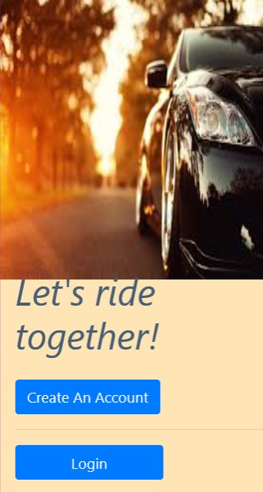

The application has 2 main pages, in the first page the user sees two buttons one is for registering and the other is for login, in the top he will see an image of a car so that he will instantly know that the app is car related, if the user is not registered then he will press the Register Button, a pop up will appear and he will input his information, email and the password those will be stored in the database, so the account will be made and next time he can just log in with the information that he inputted. After that he will enter that exact information inputted earlier in the login pop up.

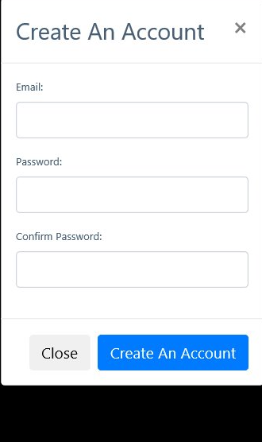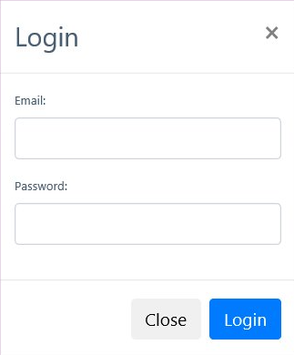

The main page has an image of a car and in the top left corner a button named “Menu”, below the image is a header “Lets ride together!” and below that is “Add a ride” and “Find a ride” links. The “Add a Ride” open a new window where the user can submit a ride, bellow he can see the Google Map route selected from the origin to destination, once the ride is submitted it will be saved in the database and the user can modify it in the menu bar. And in the “Find a ride” the user can choose the ride he needs, maybe to work if there is someone offering that ride.

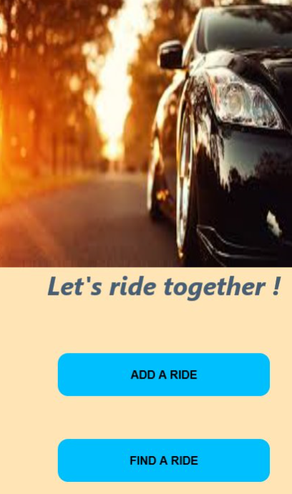

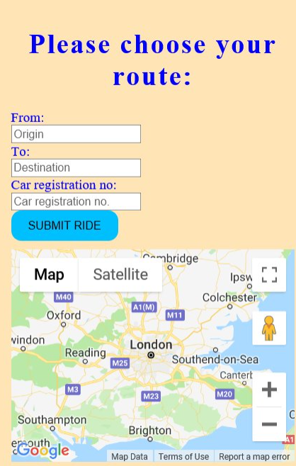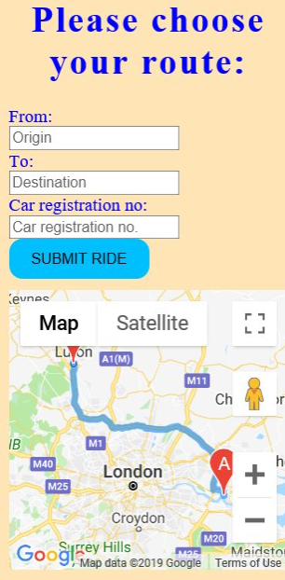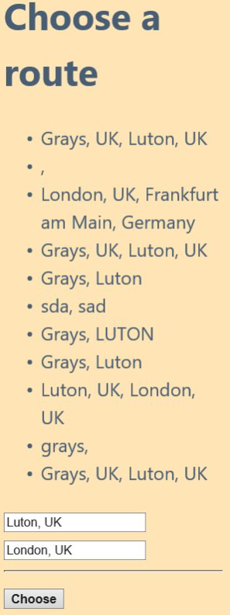

Now he is at the main page here he can by pressing the navigation button “Menu” see the “My Profile” and the “My Routes” buttons, in the “My Profile” he can add his name, city, and car by pressing “Update” and a form will appear in it he can input his details, and in the My Routes is the same but its asking for the routes.



User Evaluation

In the preparation stage of the design of the application, during one of the meetings the group decided what are the biggest user problems, on the top of the list is user friendly interface because many users leave a mobile application or a web site because it is just too much information and too many sections that make it hard to gasp a proper concept of the program. To counter this problem team 14 decided to only use friendly and easy interface because simplistic layout and concepts are better to spark the user’s interest and keep him surfing on the page.

In second place of the list are errors, the user absolutely does not like errors and will leave at once if something does not work right on the application, that is why there has been put a lot of focus so that run time errors will not occur, that every page is connected properly with each other and every button does its job as it was intended.

The navigation as well has been of much concern the client would like to see very simple navigation that works properly not something flashy, that is why it was decided to only use cascade style sheet for the navigation. Another problem that a user might encounter is struggling to comprehend what is the application about to solve this burden the only thing was to use visual comunication through an image that will give the user the felling of what the application is about. The chosen picture is an image of a car, that way the signal that it will be portraited for the application will be of cars, routes related services. The background color chosen was such that it will give a calm and relaxing felling for the users, the color used is reassuring to the eyes so that the application will be scintillating for the user.

Finally, the decision was placed and team 14 recognised about what the application need to be so that the users would be happy and use it as much as possible, it needs to be friendly and simplistic and as well to be functional, no errors and to be easy for the user to get to know from the first glance what is the application about.

When the time was right the application was presented to an audience, the users were really surprised and as well satisfied of the application, saying many complimentary words of it but without perseverance and team work from the team the application wouldn’t been so brilliant.

Now for the legal part the application IP is protected using the copyright symbol that is the easiest and fasted method to protect the app, other methods of protecting are trademarks, patents, trade secret.

Basically, copyright only protects the content (the code, image) and not your ideas, so it can protect over exact mirrored applications, trademarks protects over name, logo and lately patents the most protective method it can protect the concept and the functionality of the designed and build application but it is the most time consuming and hardest of them all.

Mobile app search engine optimization and marketing strategy

The internet marketing determines the growth levels of interaction for commercial relationships to both the future users and as well for regular users that’s why it is important for a good plan to market the mobile app.

The plan that was decided for the marketing of team 14 app is to use a short 5-minute video to promote the app, and as well to use social media, to make a web site version, to make a forum where users can discuss, to engage the audience, to ask for app reviews, user feedback and clearly defining what the problem the app solves, to work hard on the ASO (app store optimization) strategy. The team also decided that a backup plan was necessary if the options defined earlier would not produce result, so a PR firm would be the most logical solution if everything else failed.

The 5-minute video will showcase what the app is about, and it will state what problem it will solve for the user, it will introduce the user in the world of the app, making him or she feel trustful of the capabilities and features of the mobile application. The video will be uploaded on the big social media platforms like Facebook, Twitter, YouTube. And in the description of the video the link to the web site version of the app will be put and as well the link to the downloading market for it so that will improve the SEO every time a user clicks on the link.

Users need to be engaged and intrigued so what better way than to build a forum in the web page, helping user with all the question and providing relevant answers for their needs, there users can publicly make reviews and feedback of the mobile app.

One important feature of marketing is of course is SEO, and the name of the mobile application is of course a big first step to start from, the name of the mobile application needs to be iconic to reflect what its information and data is about, those were taken into consideration when the apps name was born, without any further ado the name of the mobile application made by team 14 is MyRoute, the name is easy to remember for the user and as well helps the mobile app. The description on the ASO should be impeccable and mirror what a user would search for, that will increase the SEO.

Images and videos and as well text can have a very big impact on the ranking in the SEO, that is why the video has been made to market the app.

The following SEO knowledge where considered while building the application: Meta tags, keywords, description, title, headers, image alt, videos, links that point to the website, speed of the mobile app.

Critical Analysis and reflection of the project

The team 14 project went well because of team work and perseverance not stopping when they hit a wall but finding ways to go over or around it, the design and implementation went very good and as well the programming part because both, Daniel and Marius have very good knowledge of HTML, CSS and as well Java Script. But one thing did not work quite right was the database, first team 14 were trying to connect to MySQL with PHP, but it was not working, so they found a better option and that is Firebase, that is a database offered by Google.

The project was good and if they could do it again they would add more interactivity into the application. In the future the Team 14 will do more projects together and look to improve their knowledge, most of the files have been shared with each other through Google Drive and most of the communication where done by calling and video conferences except when meetings where necessary.

The team leader for this project is Daniel Andrei, he has driven this project forward and his work is very significant in the programming of the app and he contributed in the report, as for Daniel Andrei his work is very significant in the report and he contributed to the code, Daniel at the end of the project made the video where he showed the functionality of MyRoute, and he did the .apk and zip file, in the code he did the “Profile” and “My Route”, while Marius surprised Daniel and he implemented the Google Map API, and did the Main menu, the register and login forms and as well the first page of the app.

This is what team 14 did, both of them highly motivated to learn and to show what they learned from the mobile application development sessions, both of them showed fantastic skills while build the app in HTML, CSS and in Java Script and using the database Firebase.

Team 14

|  |  |  |  |
| --- | --- | --- | --- |
| Members | Coding | Report | Conduct |
| Daniel Andrei | Brilliant | Extraordinary | Exceptional |
| Marius Luntraru | Fantastic | Remarkable | Incomparable |